IMMUNE RESPONSE
The specific reactivity induced into a host by an antigenic stimulus is known as Immune response. It may also be defined as the response of the body towards the entry of a foreign substance either living or non-living. The consequences of the response may be beneficial or injurious to the host. But the ultimate aim is to destroy and eliminate the antigen. The immune response can be of two types- The humoral (Antibody mediated) and Cellular (Cell mediated) immune responses. These two usually act together or one may predominate the other.
The antibody mediated immunity provides protection by producing antibodies and it acts as the primary defense against many extracellular pathogens and also protects the respiratory and gastrointestinal tracts against viral infections. It also participates in hypersensitivity reactions. The cell mediated immune response protects against fungi, viruses and intracellular bacterial pathogens. They also play a role in graft-versus-host reactions and in immunity against cancer.
Humoral Immune Response(HIR): The destruction of Ag’s by producing Ab’s is termed Ab-mediated immune response. Since the Ab’s are present in the humors(body fluids) it is also known as humoral immune response. As it is brought about by Bcells, it is also termed B cell mediated immunity. B cells on activation differentiate into effector cells (Plasma cells) and memory cells. B cells alone cannot bring about Immune response. They need the cooperatin of Macrophages, T_{H} cells and dendritic cells.
The humoral response to antigenic stimulus varies both qualitatively and quantitavely based on the antigenic interaction. If the encounter is for the first time, naïve lymphocytes are activated and the response is called primary response. If the same animal gets encountered with the Ag for the second time, the memory lymphocytes are activated and the response is called the secondary response. If the Ag is injected purposefully, it is referred as primary dose in the first case, and secondary dose is called the Booster dose which generated secondary response.
The HIR results in production of Abs in the plasma. The amount of Abs produced (Ab titre) when plotted against time, gives a sigmoid curve called IR curve. It consists of 4 regions, a lag phase, log phase, Plateau phase and a Decline phase. The primary response is slow, sluggish and short lived.
- Lag Phase: The lag phase is long. During this phase the naïve Bcells undergo clonal selection and differentiate into memory cells and plasma cells. IgM is the first Ab to be secreted. There is no detectable circulation Ab in this phase.
- Log phase: A steady rise in Ab titre in the circulation is seen. IgM is the first Ab to be secreted and then a switch to IgG with increased concentration is observed.
- Plateau Phase: This is the period in which Ab titre is stable. An equilibrium is attained beween Ab synthesis and catabolism.
- Decline Phase: A fall in Ab titre is observed. This is due to increased catabolism.
The capacity of a person to develop secondary Immune response depends on the memory cells formation during the primary response. The memory cells formation during the primary response. The memory cells enter the Go Phase of the cell cycle. Their life span is variable; few are known to persist through out the life of an individual.
Secondary response has a very short lag phase. This is because the memory cells are more easily activated when compared to the naïve B cells. During the log phase, Abs having high affinity are produced. They are also of different isotypes. But combindly, they contribute to very effective host defence system against the reinfected Ag. IgG constitutes the major part of Ab’s with a very low concentration of IgM. The secondary immune response has an extended Plateau phase which is then followed by a decline phase.
Factors influencing Ab Production:
- Genetic factors: The differences shown by individuals of the same species for a particular Ag are determined by their genetic differences. The Ir (Immune reponse) genes control this property. Based upon the individuals capacity to respond to a particular Ag varies, and they are categorized as Responders and nonresponders.
- Age: The embryo is immunologically immature. It starts producing Ab only after the development of lymphoid organs. The age at which the embryo acquires this capacity varies with species. But during the embryonic life, the developing lymphoid cells are made to come into contact with all the tissue Ag or the cellular breakdown products of the body. So, the clones which have specificity to the self Ag’s are eliminated. In human Ab production starts at the age of 3-6 moths. By this time the maternal Abs start to disappear. Full immuno competence is achieved only by about 5-7 yrs for IgG and 10-15yrs for IgA. The nature of Ag also determines the age by which immunocompetence is achieved. The response to T cell dependent Ag develop earlier when compared to T independent Ags.
Nutritional status: Protein calorie malnutrition effects both humoral abd cell mediated immune response. The CMIR is affected adversely. Deficiency in Tryptophan , Phenylalanine, Methionine, Glycine, Isoleucine and Vitamins (A,B group factors) decrease Ab synthesis.
4) Routes of administration: Route of Ag administration effects IR. When small soluble Ags are given through oral or nasal routes, humoral IR is found better. Large particular Ags, such as bacteria and virus when injected into tissues, they were found to induce cell mediated IR better.
Eg: IgA is produced by oral or nasal admistration. When pollen is induced by nasal route, it induces IgE, but when injected it induced IgG Ab.
5) Size and Number of doses: Ags when injected at above minimal critical doses, induce IR effective. When given above a level they tend to inhibit IR and induce tolerance.
Eg: Mice injected with 0.5μg Pneumococcol capsular polysaccharides produce specific Ab’s, but when injected at 50μg concentration, the system fails to form Ab. The massive antigenic stimulus appears to swamp the Ab producing system and paralises it. This phenomenon is called Immunological Paralysis (Felton 1949). Repeated Ag administration increases Ab titre value till certain extent, but beyond a certain limit there will be no effect.
6) Multiple antigens: When two or more Ags are given simultaneously, the Ab response to one or the other Ag may be enhanced and the response to the other may be diminished (Antigenic competition).
a) When typhoid and cholera vaccine are given together, they do not effect each other.
b) When a toxoid is given along with bacterial vaccine, toxoid acts as a potential inducer.
c) When diphtheria and tetanus toxoids are given together with oneinexcess, Ab production against the other is inhibited.
d) Incase of triple vaccines, DPT(Diphtheria, Pertusis and tetanus), when the person receives a primary dose, response against diphtheria is enhanced.
7) Adjuvants: Substances which enhance IR.
8) Immunosuppressive agents: Used to prevent graft rejection. Examples include X-ray irradiation, radiomimetic drugs, corticosteroids, antimetabolites and other cytotoxic chemicals and antilymphocytic serum.
a) X- ray irradiation: Sublethal whole body irradiation is known o suppress Ab response. If an Ag is introduced after 24h of the irradiation, Ab production does not occur. Where as, if an Ag is given 2-3days before irradiation, Ab response is enhanced. The primary response is more sensitive than the secondary response.
b) Radiomimetic drugs: They belong to the class of alkylating agents. Eg: Cylcophosphamide, Nitrogen mustard. Phosphamide when given 3days after the Ag is given leads to effective suppression of Ab response.
c) Corticosteroids: Causes depletion of lymphocytes in the circulation as well as lymphoid organs. They inhibit some cells releasing histamines and therefore play a role in inhibiting inflammatory response. In human, they have little effect on Ab formation, but are very effective in rats and mice. They also inhibit the induction of delayed type hypersensitivities.
d) Antimetabolites: These are substances that interfere with the synthesis of DNA and RNA and thus inhibit cell division and the differentiation necessary for the generation of humoral and cellular immune response.
Eg: Folic acid antagonist- Methotraxate.
Alkylating agent -Cyclophosphamide
Analogues of Purines- 6-mercaptopurine, Azathioprine
Analogues of Cytosine- Cytosine arabinoside
Analogues of Uracil- 5-fluorouracil
Cyclosporine: Most widely used immunosuppressive agent. It is a cyclic polypeptide derived from the soil fungus Tolypocladium inflatum. This selectively inhibits T_{H} cell activity. It has no antimitotic activity. Other related drug is rapamycin.
Other examples: Sera are used for Immune suppression.
ALS: Antilymphocyte serum, raised against lymphocytes.
ATS- Antithymocyte serum, raised against T cells.
9) Effect of Ab: HIR can be suppressed by passive administration of Ab. A mechanism similar to feed back inhibition operates. This is applied in the prevention of Rh sensitization of Rh-ve mother carrying Rh+ve fetus. They introduce antiRh globulins following delivery (within 72h). this method used in treatment of mainly autoimmune diseases of blood. Eg:autoimmune lymphocyte anemias.
10) Mitogens: Substances inducing division of lymphocytes are called mitogens. Eg: Lectin glycoproteins-bind to sugars on the surface of responsive cells, activate them leading to polyclonal response.
Steps involved in B cell activation:
- Selection of B cells
- Recognition of Ag
- Processing of Ag by Macrophage.
- Antigen presentation.
- Triggering of the B cells
- Clonal proliferation
- Production of plasma cells
- Secretion of Immunoglobulins.
Cell mediated Immune Response(CMIR):
When Ags are destroyed by cells without producing Abs, the immunity is called CMIR or cellular immunity. The cells that are involved in this immunity are Macrophages, T cells, Eosinophils, Basophils and NK cells. The Macrophages, T cells, Eosinophils, Basophils and NK cells are non-specific, but T cells are Ag specific. The Ags that cannot be handled by Abs are processed by these cells. For Eg: An Ag say a bacteria or virus has invaded ac ell and remains inside a host cell. Scuh cells are processed and Ag is presented to the Tcells. The cells involved in the processing are Macrophages. The Tcells are of 2 types. The Cytotoxic T Lymphocytes (Tc cells or CTL’s) having specific CD8⁺ receptors on their surface and the T helper cells (T_{H} cells) having CD4⁺ receptors on their surface along with the Tcell receptors(TCR’s). The T_{C} cells recognize Ag along with MHC class I molecules, which are present on all cells. The T_{H} cells recognize Ags when presented along with MHC class II molecules present on macrophages.
Mechanism of Tcell mediated Immunity: The cells involved are Tcells, macrophages and NK cells. The Ags dealt are cellular Ags or protein Ags. Steps involved include:
1) Recognision of Ag: When a host is infected with viral Ags, the cells express viral capsids on their surface. The cytotoxic T cells recognize these Ags on the infected cells which have MHC class I molecules on their surface. The MHC classI molecules present the Ags to the Tc cells and this Tc cells bind to the Ag using their T cell receptor(TCR) along with CD8⁺ molecules. Around 10% of Tc cells express CD4⁺ receptors that recognize Ag presented by the MHC class II molecules of APCs.
The cells which do not express MHC class molecules, but are infected or, the Ag present on a target cell is involved in Ag-Ab complex are processed by NK cells. The NK cells have CD16 marker which are receptors for Fc fragment of Ab. This is during the primary immune response. Ones the naïve Tc cells are activated, they become the effector T cells which are called the cytotoxic T lymphocytes (CTL’s). These cells have lytic capability and are critical in recognition and elimination of altered self-cells (Eg: virus infected cells and tumor cells) and in graft rejection.
CTL mediated immune response: It has 2 phases
- The first phase constituted activation and differentiation of naïve Tc cells into functional effector CTL’s.
- Effector CTL’s recognize Ag expressed on MHC class I molecules and finally destroys the target cell.
The CTL’s are formed from naïve cells called CTL precursors which are incapable of killing target cells. Their transformation into functional CTL’s require 3 sequential signals.
- An Ag specific signal transmitted by the TCR complex on recognition of a peptide-classI MHC molecule complex.
- A co-stimulatory signal transmitted by the CD28-B7 interaction of the CTL-Ps and the APC.
- Signal induced by interaction of IL-2 with the high affinity IL-2 receptor, resulting in proliferation and differentiation of the Ag activated CTL-Ps into effector CTL’s.
(IL-2 is a cytokine required for proliferation and differentiation of activated CTL-Ps into effector CTL’s. Principally IL-2 is secreted by Ag-activated CTL-Ps and proliferating T_{H} cells.)
2. Ag processing for TD Ag’s by macrophages(APC): The dendritic cells and macrophages constitute the classical APC. They express class II MHC molecules on their surface. The dendritic cells are most effective cells, which can activate naïve T_{H} cells. Macrophages are also Antigen presenting cells. They are activated by phagocytosis or endocytosis of an Ag before they express the MHC class molecules or the co-stimulatory B7 membrane molecules. B cells express ClassII molecules, but they must be activated before they express the costimulatory B7 molecules.
The other nonprofessional APC’s like fibroblasts of skin, glial cells of brain and pancreatic beta cells can also be induced to express class II molecules. These process the Ag and eliminate non-immunogenic components and only immunogenic component is deposited on the cell surface via MHC molecule.
3. Ag presentation by APC: The immunogenic component of T dependent Ag’s is brought out via the MHC class II molecules which will be recognized by T_{H} cells.

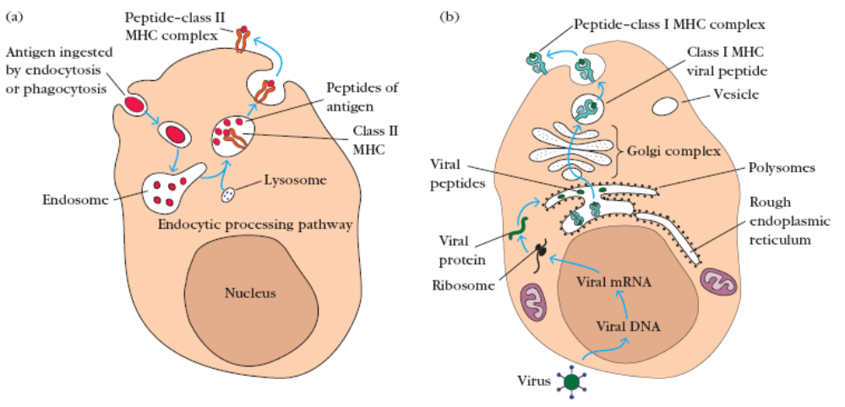

4. Binding of T cells:
a) Tc cells: these cells recognize Ag via MHC class I molecues through their CD8 and TCR. CD28 and B7 interactions must also be completed.
b) T_{H} cells: These cells recognize Antigenic peptides presented by APC’s via MHC classII molecules through their CD4 and TCR.
5) Clonal proliferation: The Tc cells get activated and IL-2 secreted by T_{H} cells make them proliferate and several Tc cells acre formed. In the same way T_{H} cells also have receptors for IL-2 which result in auto activation and make them for several clones.
6) Secretions of Tc cells: The cytotoxic lymphoid cells degranulate releasing perforin and various enzymes into the immediate vicinity of the target cell membrane. In the presence of Ca²⁺, there is enzymic polymerization of the perforin to form polyperforin channels on the target cell. The CTL’s release enzymes which activate apoptosis pathway or they release degradative enzymes or other toxic substances, which pass through the channels and damage the target cell. They finally result in killing of Ag infected cells or altered cells.
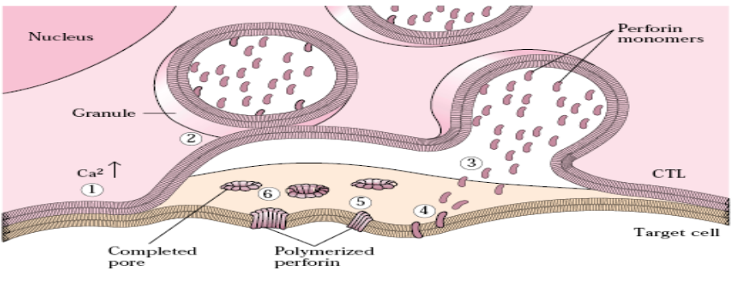

7) Secretions of lymphokines by T_{H} cells: Based on the cytokine profile, the CD4⁺ T cells are divided into subsets.
a) T_{H}1 cells- They secrete IL-2 which induced proliferation of Tc cells and B cells and IFNγ (Gamma interferon) which induces Ab production.
b) T_{H}2 cells- They produce IL-4, IL-5, IL-6, Il-10 and IL-13. These are involved in the activation of B-cells and promote their differentiation and maturation.
These secretions produced by the T_{H}2 cells stimulate B-cells to proliferate and differentiate and result in the production of antibodies. These antibodies bind to the Ag and help in its elimination.
Biological functions of cell mediated Immunity:
- Immune surveillance: Invovles watching for Ag, recognition and killing of tumor cells.
- Graft rejection: Transplantation of tissues between genetically non-identical individuals of the same species is called allograft. Its rejection is mediated by cell mediated IR.
- Delayed type hypersensitivity reaction: The allergic reaction occurs slowly and it is brought about by T_{DTH.}
- Immunity to viral infections: It is by Tc cells. Interferons released by T cells also exhibit antiviral activity.
- Immunity to bacterial infections: Interferon gamma promotes by phagocytosis.
- Immunity to parasites: T cells and macrophages eliminate Leishmania, Plasmodium, Trypnosoma etc. Interferons play a role. Eosinophils kill parasites like Schistosoma and Ascaris.
CYTOKINES
These are intercellular messengers or peptidemediators which regulate immunological, inflammatory and reparative host responses. They are harmone like substances and are active even at 10⁻¹⁵M (femto molar) concentrations. They have overlapping effects.
Lymphokines: These are biologically active substances released by activated T lymphocytes.
Monokines: Substances produced by monocytes or macrophages.
Interleukins: These are also lymphokines, but they exert a regulatory influence on other cells.
Interferons: These are growth factors.
Chemokines: These are low molecular weight cytokines that affect chemotaxis and other aspects of leukocyte behavior.
Examples of Lymphokines:
1) Affecting Macrophages: a) Migration inhibiting factor(MIF).
b) Macrophage activation/aggregation factor(MAF)
c) Macrophage chemotactic factor(MCF)
2) Affecting lymphocytes: a) Blastogenic factor(BF/MF)
b) T cell growth factor(TGF)
c) B cell growth factor(BGF)
3) Affecting granulocytes: a) Chemotactic factor(CF)
b) Colony stimulating factor(CSF)
4) Affecting cultured cells: a) Lymphotoxin(LT)
b) Interferon (IFN)
c) Tumor necrosis factor (TNF)
5) Others: a) Skin reactive factor (SRF)
b) Transfer factor(TF)

Interleukins:
IL-1: This interleukins is stable netween pH 3-11 and remains active upto 56ºC. it exists as two molecular forms α and β. It is secreted by macrophages and monocytes. Production is stimulated by Ag, toxins, injury and inflammatory processes. IL-1 stimulates T cells to release IL-2 which activates B cells for the production of antibodies.
IL-2: It is the major activator of T and B cells and it stimulates cytotoxic Tcells and NK cells. It converts some null cells(LGL’s) which can destroy NK resistant tumor cells. This property is used in the treatment of cancer.
IL-3: It is a growth factor for bone marrow stem cells. It stimulates multilineage hematopoiesis and is therefore known as the multicolony stimulating factor.
IL-4: It is also known as B cell growth factor(BCGF-1). It stimulates resting Bcells resulting in their differentiation. It also acts as a growth factor for Tcells and mast cells. It also enhances action of cytotoxic Tcells.
IL-5: Previously known as Bcell growth factor II. It causes proliferation of activated Bcells. It also induces maturation of eosinophils.
IL-6: It is produced by T and Bcells, macrophages and fibroblasts. It induces Ig synthesis of Bcells and also induces IL-2 receptor formation by Tcells. It also has a stimulatory effect on hepatocytes, nerve cells and hematopoeitic cells. It also acts as inflammatory response mediator in host defence against infections.
CSF(colony stimulatory factor): It stimulates the growth and differentiation of pleuripotent stem cells in the bone marrow. They are named after the type of colonies they induce in soft agar cultures. Eg: GranulocyteCSF and MonocyteCSF. IL-3 is a multiCSF.
TNF(Tumor necrosis factor): It occurs in two forms α and β. TNF-α causes wasting syndrome. It is produced by Macrophages and monocytes and induces hemorrhagic necrosis in certain tumors. TNF-β also known as formerly as lymphotoxin, is principally produced by T_{H} cells.
Interferons: These are antiviral agents and are classified into 3 classes. Their production is activated by mitogens, antigens or exposure to IL-2.
  - IFNα- principally produced by leucocytes
  - IFNβ- produced by fibroblasts
  - IFNγ- produced by T cells. It has multiple effects. It activates macrophages, neutrophils and regulated monocytes functions. Also has antitumor activity.
Other cytokines:
- Transforming growth factor beta (TGF-β)- Transforms fibroblasts and promotes wound healing.
- Leukemia inhibitory factor(LIF): Produced by Tcells, helps stem cells proliferation and eosinophils chemotaxis.
- Transfer factor(TF): Its molecular weight is 2000 to 4000da, resistant to trysin, DNA-ase, RNA-ase and freeze thawing. It is inactivated at 56ºC in 30minutes. it is reported to be composed of polypeptide-polynucleotide complex. TF has the capacity to transfer CMIR and cannot transfer HIR. It is capable of inducing antigenically uncommitted lymphocytes to produce Ag specific receptors.

